What-is-eco-friendly-technology
What is eco-friendly technology is a place where we share and learn typeâs sustainable technologies that is renewable, sustainable and alternative to upkeep sustainable living, in terms of agriculture, economics and technology to the environment.

Let’s find out, what eco friendly technology really is …
It can be individual or sets of sustainable technologies, that can apply in order to preserves the environment by using the alternative and renewable resources which is abundant, easily replenished, least harmful materials and methods so as to reduce the harmful waste to avoiding pollution that is toxic to our ecosystem and also the atmosphere which may cause impact of climate change and global warming.Â Eco technologies also use energy efficiently to reduce the amount impact to the eco systems fulfilling the sustainable living and agriculture where new methods and innovative science introduce so as to reduce the impact on the environment.Â Useful materials are also being research to minimized impact to the environment and also the human body. Other than depending on technology, we also need to play our part in our day in choosing the products and methods or ways improve our lifestyle to keep it sustainable.

What is eco friendly technology and what does it involve?
Eco friendly technologies involved making use of alternative energy source which is abundant to generate renewable energy, reducing the amount of resource which is limited used through the conventional like fossil fuel.Â For example renewable resources like sunlight, sea water and co2 which are abundant generating alternative resource like biofuel, solar energy, freshwater and air purification through greenhouse, vegetation and halophytes cultivation stabilize the degraded desert soil and as wind breaks reduce the impact of pollutants on the environment.
In some areas of green technologies such as water recycling and purification through natural less destructive renewable methods used for seawater in the dessert environment is not burden with the waste while creating opportunity to produce various products afresh. These are also cheaper as well as using these waste materials recycle it in order to produce the new goods and products. This makes eco technologies cheaper for the producer and manufacturer in the long run. This is because though you may not see the savings right away when you start using sustainable technologies, you will realize that the money you save long term will be quite substantial.
Using biodegradable materials can be advantage for the reducing waste and impact to the environment and the human body.Â These materials having multiples characteristic making electronics circuits, tiny, flexible, stretchable and capable of dissolvable completely or partially enable us keeps our earth sustainable through reducing the amount of electronic waste polluting the landfill.Â Scientist like Professor John Roger and his working universities has announced making electronic component having environmentally safe electronics that also vanished in body and disappearing act,Â being capable completely vanish or partially disappear benefit health and the environment possible opportunities improving lifestyle and our environment.Â However, research and qualification and certification are required to get product approved.
Sustainable agriculture ensures that agricultural goods and products produced have fewer chemicals and are more organic whilst maintaining healthier soil quality and nutrients through various methods like recycling, rotating crops, composting replenishing nutrients and prevent pest through biological control reduce use of synthetic pesticides and fertilizer minimizing landfill from degraded. Â Jute fiber is an example having many areas for use and leaving minimal waste and footprint to the environment.
The other benefits of knowing what eco friendly technology are how waste is reducedto the environment. Â Â Ways or method making product that made from material preserved the environment and therefore does not degenerate at a fast rate is also eco friendly. Â This is because when there is less waste produces, during the manufacture or production of products and the energy used is renewable which is less stressful on the environment there is less pollution and polluting chemicals and other substances.
In summary, all the above brings beneficial to our environment through:
- Renewable energy
- Sustainable living
- Sustainable agriculture
- Sustainable environment
One of the withdrawals of using eco friendly technology is that it can be expensive to start using this kind of technology. This is because you may have to overhaul the current systems that you have. For example, if you would like to use solar energy in addition to electric or gas power then you will have to install a solar power system which involves solar panels, a storage battery and other components depending on the your needs and the kind of solar system that you would like to install.
As the technology develops and becomes widely acceptable, what is eco friendly technology is a question that many people will be able to easily answer.Â However, time is need while often more researched need for monitoring the progress.
ecoATM
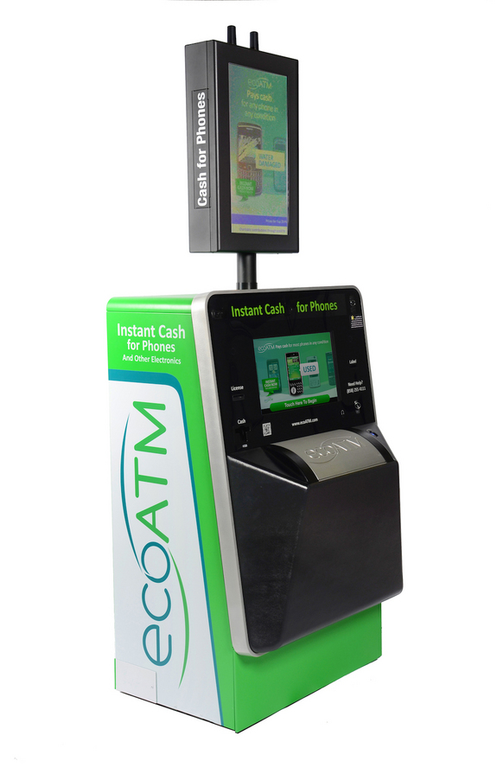
EcoATM is a stand-alone machine (it looks kind of like a RedBox or CoinStar machine) that allows users to exchange old electronics for cold, hard cash. While it's not exactly new (the first ecoATM launched in 2009), this product was a hit this year at CES, where onlookers crowded around to watch the machine assess the value of beloved smartphones.
The electronics that ecoATM reclaims can be mined for the valuable and rare metals they contain. By recycling your old devices, you can prevent toxic mining waste from being poured into the environment, according to the company. And by keeping electronics out of the garbage dump, you also prevent the toxic materials found inside these devices (things like mercury and cadmium) from leaking into the ground.
Of course, not all of the electronics that find their way into the ecoATM are actually taken apart and used for parts. Most of them are resold to new owners, a company spokesperson told Live Science. (Photo Credit: EcoATM)
Solpro
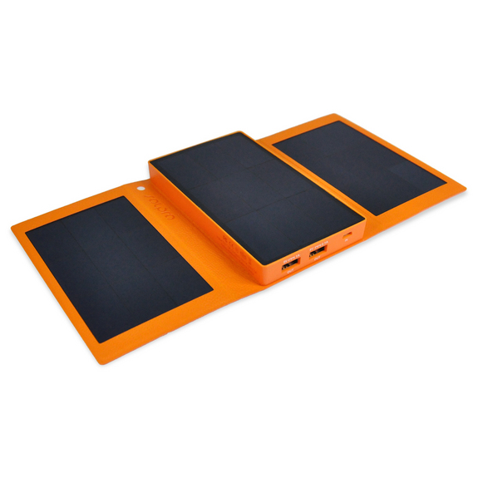
Of course, the Misfit Shine isn't the only product at this year's CES that gets its power from the sun. Solar tech company Solpro unveiled its new solar-powered phone-charging device, the Helios Smart, this week, as well.
The device is a pocket-size rectangle that unfolds to reveal three solar panels. These panels can absorb enough sunlight in 90 minutes to charge a standard smartphone, according to the company. The Helios is ideal for those who are on the go and don't feel like hunting for a charging station, or those who are living off the grid (even if just on a camping trip). But Solpro CEO Bill Pike thinks the device is a good solution for everyday charging, as well.
"It won't be just for camping and emergencies," Pike told Live Science in an email. People want alternative, sustainable options for generating energy, he said. (Photo Credit: Solpro)

Audi Electric Car
Audi A1 project Quattro concept electric Car
Audi have joined the race to develop a viable electric car, confirming that they plan to launch a range of electric cars within the next five to ten years.
They recently unveiled their A1 project Quattro concept electric car (pictured above).
The Audi A1 follows hot on the heels of the Audi R-Zéro - a battery-powered super car.

Floating Wind Turbines
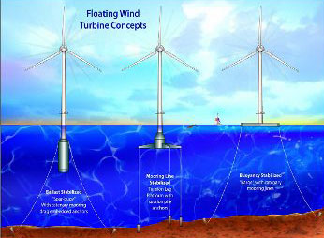Floating Wind Turbines
A number of companies including British based Blue H are competing to develop the world's first floating wind turbines. These turbines benefit from more powerful winds out at sea yet avoid many of the issues that afflict existing wind farms.
Floating wind farms are potentially more economical than fixed wind turbines as they avoid the cost of constructing fixed foundations in the seabed. They could also circumvent problems with planning, as well as having less impact on shipping, military radar and coastal seabird populations.
Other proposed non-permanent maritime wind turbine solutions currently being developed including Hywind, where conventional turbines fixed to a concrete buoy, anchored to the sea bed with three cables, and the Sway turbine - an elongated floating mast, the bulk of which sits below the water, connected to the seabed by a metal tube.

Home Energy Generation

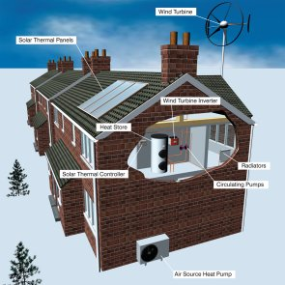
If a substantial number of UK homes were fitted with micro energy generating equipment such as solar panels and wind turbines it could generate as much electricity as five nuclear power stations. So concluded a report commissioned by the governments' Department for Business, Energy and Regulatory Reform (DBERR)
This could be achieved through a combination of loans, grants and incentives and could lead to nearly 10m microgeneration systems being installed by 2020, and could save 30m tonnes of CO2 – the equivalent of nearly 5 per cent of all UK electricity.
Here is a selection of Home Energy Generation Technologies:
• Solar thermal
Solar thermal panels are the most popular green technology in Britain. They use sunlight to directly heat water flowing through a network of tubes across the surface of the panels. Fitted to roofs they can provide cheap, carbon neutral hot water.
• Combined heat and power units
The basic principle behind combined heat and power units, is that by generating your power requirements 'on-site' you are able to utilise waste heat from the energy generation process, for heating and hot water etc. See Combined heat and power units for more information. Combined heat and power units can be very eco friendly if the technology used to create the electricity produces very little carbon such as a biomass boiler or stove (see below).
• Biomass boilers and stoves
Biomass boilers and stoves burn wood chips and pellets to provide heat and power.
• Heat pumps
Heat pumps utilise the difference between underground temperatures and those in buildings to act like a fridge in reverse. Heat from underground is transferred into the home. Heat pumps are common in Scandinavia and the technology is growing fast in the UK.
• Micro-hydro
The ancient technology of the water wheel is coming back into common usage with energy from running water converted to electricity. These units are being fitted to old mill races, and are being installed in rivers. Depending on flow, they can provide enough electricity for hundreds of houses.
• Solar photovoltaic panels and film
Solar photovoltaic panels and film convert sunlight directly into electricity. The technology is developing rapidly as billions of dollars are invested in it in the US. It is hoped that the price of solar panels will fall as China takes over production lines and economies of scale in production become possible.
• Micro-wind
Small scale wind turbines can generate enough electricity for companies and householders to become self-sufficient. An attractive proposition as electricity prices rise.

Paper Bottles

Paper Bottles
The 360 is a paper bottle created by the designers Brand Image. It is molded from 100 per cent recyclable, food-safe, paper. The 360 is cheap and easy to produce, stackable and re-sealable, making it a viable alternative to plastic bottles.

Recycled Plastic Concrete
Recycled Plastic Concrete
Concrete is not the most environmentally friendly material, so any innovation to mitigate its impact is welcome.
Architect and engineer Henry Miller has developed a process to make concrete using two-thirds granulated plastic, which it is as strong as conventional concrete.
Concrete is usually 60% to 75% aggregate, consisting of sand, gravel or crushed stone. In Miller's process waste plastic that would otherwise end up in landfill or heat-related processing, is ground up and then mixed with pure concrete. This process has the added environmental advantage of avoiding the use of mined gravel or sand. Bricks made using this process can withstand 3000 to 5000 psi.

